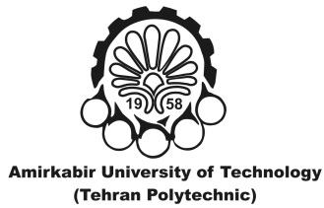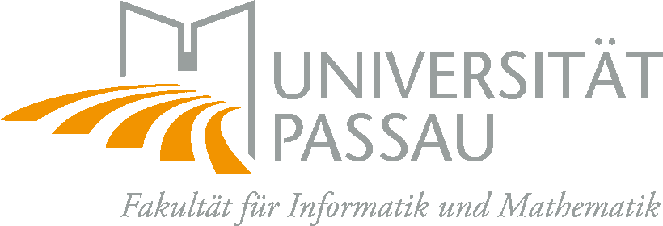

**Information on the Erasmus+ Scholarships  
for Iranian Master Students  
*Academic Term Summer 2019***

Erasmus+ is the EU’s programme to support student mobility between European countries and partner countries. Students from AUT benefit from grants to study abroad at the UP. This will allow them to expand their horizon by studying in Germany and expose themselves to new experiences and opportunities. This handout is supposed to provide some information on the Erasmus+ programme and the application process.

Information on English-taught courses can be found here:

<https://www.fim.uni-passau.de/fileadmin/dokumente/fakultaeten/fim/dekanat/Veranstaltungshinweise/Welcome-Meeting-Master-CS-MES.pdf> (short link: https://bit.ly/2OFVMwK) . Note that not all courses are given in each term, see <http://www.fim.uni-passau.de/en/study/course-catalogue/> .

**Two** exchange students can be supported with a scholarship of **3930.00 EUR** in total for summer semester 2020 (including a one-time travel allowance), in order to study in the International Master Program in Computer Science at the University of Passau. The scholarship is roughly sufficient to cover cost of living in Passau.

**Important:** Students need to apply for a residence permit while living in Passau. The month of August will not be covered by the scholarship, so you need to have proof of sufficient funding (**853 €**).

The timing is as follows:

|  |  |  |
| --- | --- | --- |
| **NO.** | **Action** | **Deadline** |
| 1. | Announcement | Nov 25th |
| 2. | Application Submission Deadline | December 2st |
| 3. | Applicants Admission (Main + reserved) | December 8th |
| 4. | Application Submission by Admitted Applicants to Passau | December 15th (by post: January 7th) |
| 5. | Apply for Visa (no later than) | January 31st |
| 6. | Start Date | April 6th |

The interested applicants should pass the following documents to the deputy of research office of the department of Computer Engineering and Information Technology:

* CV
* Bachelor transcript
* Statement of Purpose of your stay in Passau (motivation letter)
* Proof of English proficiency (can be issued by AUT)

The successful candidates must additionally enroll at the University of Passau by December 15th. The following documents must be enclosed with your application:

* The [application form for accommodation](http://www.uni-passau.de/index.php?id=4941&L=1) if you wish to apply for a room in a student residence,
* A copy of your High School Diploma (A-levels),
* A copy of your passport or national ID,
* 2 passport size pictures.
* A proof of your knowledge of English and German (not both),
  + We will not require a language test (TOEFL, or the like), instead we will also accept a certification from AUT that the student speaks and writes English well enough to follow lectures in English and to take examinations in English.
* A copy of your Bachelor Diploma.
  + We will not require translated copies of diplomas, it is sufficient that AUT officially certifies in an English letter that the students earned a bachelor degree and confirms the grade the students received. Please be aware that you should achieve 20-30 ECTS points per semester during the stay at the University of Passau, you should choose your courses accordingly.

It is not guaranteed that we can supply housing in Passau, but help is offered at the University of Passau and if you choose to look elsewhere for a shared apartment, this service is recommended: <http://www.wg-gesucht.de/en/> . Support for International Students at the University of Passau: [master-help@fim.uni-passau.de](mailto:master-help@fim.uni-passau.de)